Install and Configure Jenkins on an AWS EC2 Instance

RedHat instance created:

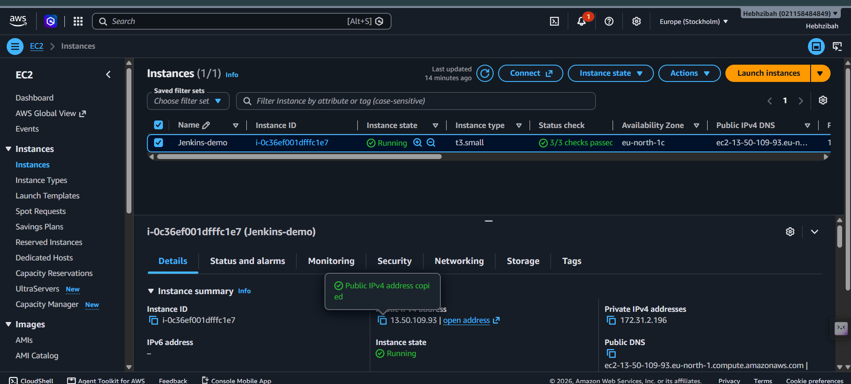

Java installed:
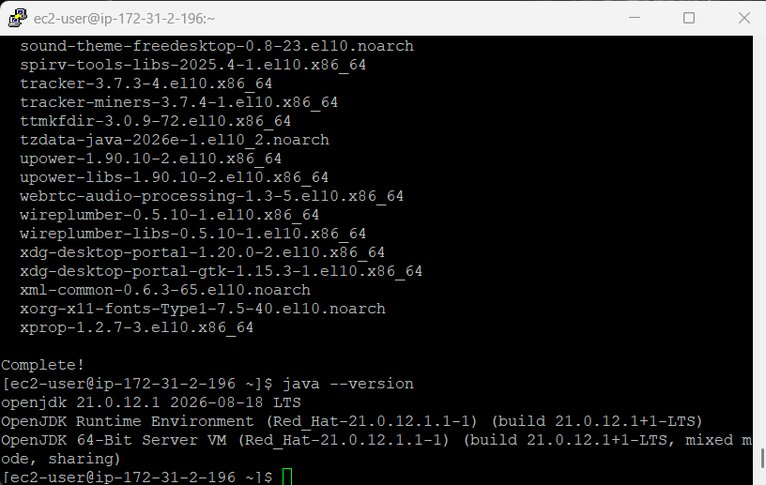
Checking Status of Jenkins:
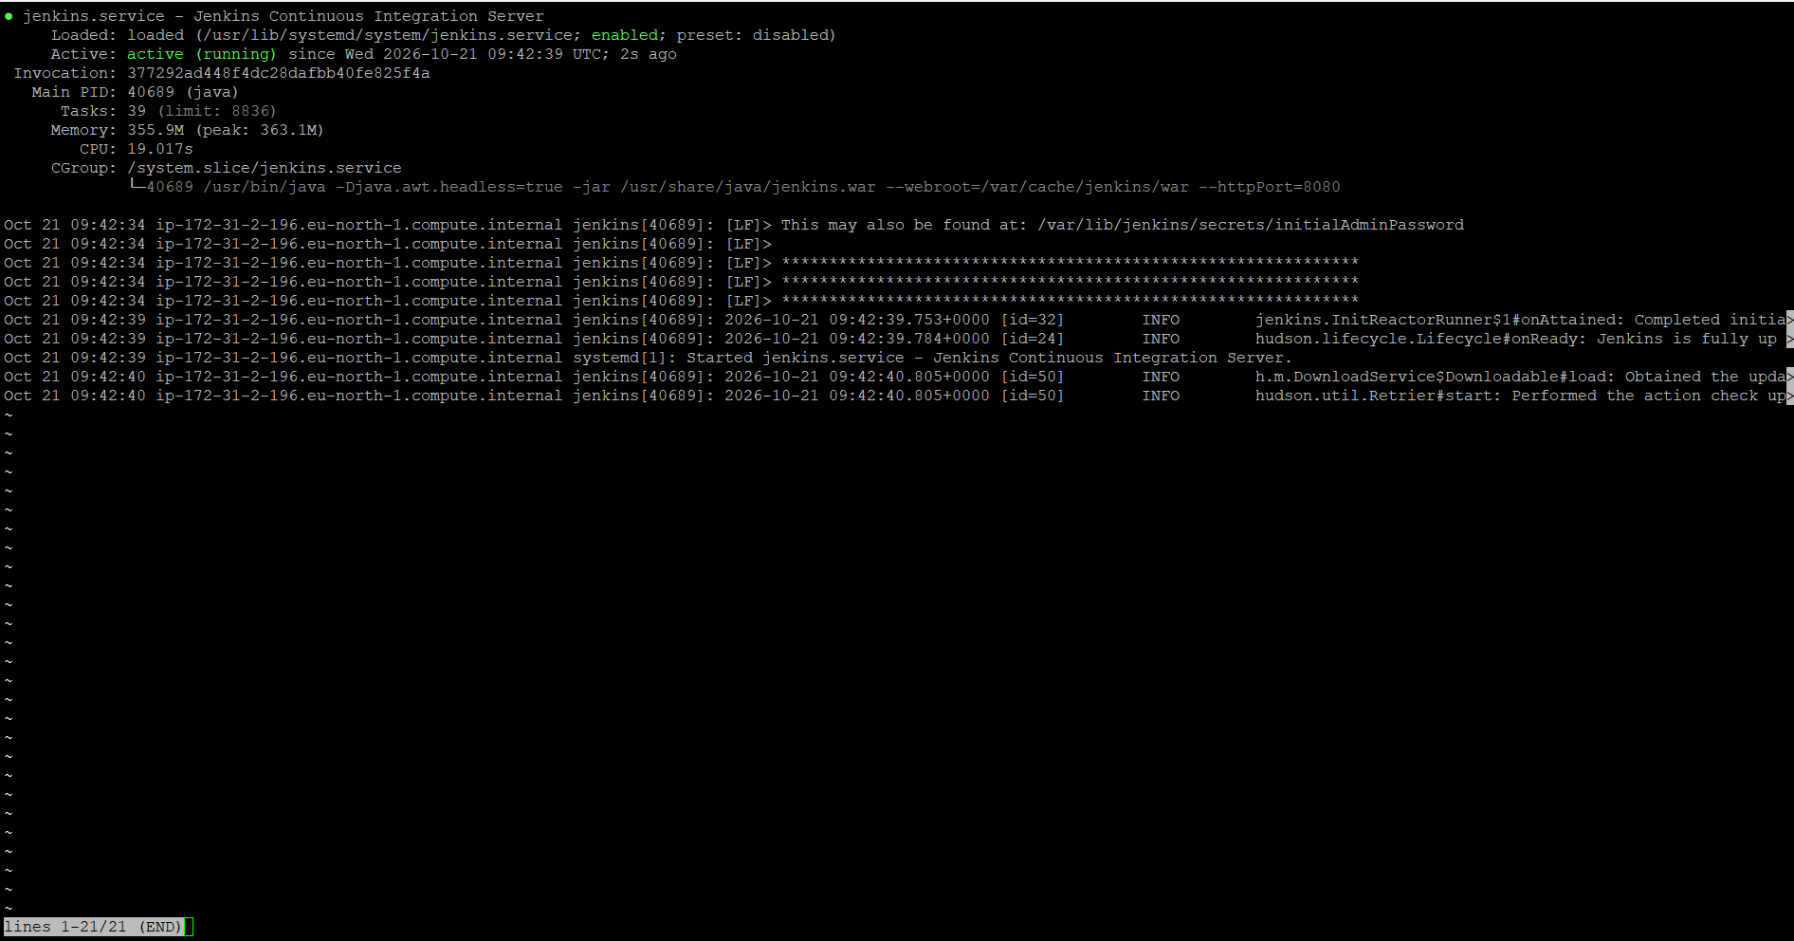

Accessing the Jenkins dashboard through a web browser:

